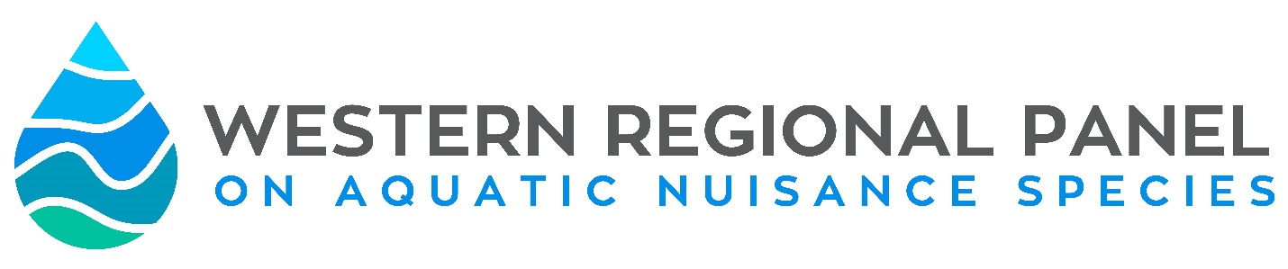Membership Application
The Western Regional Panel on ANS is open to membership of interested persons/organizations seeking to positively influence the issue of aquatic invasive species in North America. The WRP relies on the participation of active voting members to accomplish a variety of tasks associated with WRP business and regional efforts.
This membership application is intended for Other Interest -Individuals or Organizations membership categories. A complete list of these membership categories can be found below and as Appendix A of the Bylaws.
Requirement of the Membership: As a voting member of the WRP, the Panel expects that every individual will actively contribute at least one year of service to one of the standing committees, or workgroups.
Duties of the Membership
- Participation in Panel meetings, and on Panel and ANS Task Force committees and workgroups.
- Enhance coordination of Panel activities through communication of ANS management and policy initiatives to other Panel members via presentations at the Annual Meeting.
- Communicate the Panel’s activities and recommended actions to the organizations they represent (where applicable), and strive to improve the organization’s ability to address ANS impacts both internally and through collaborative partnerships.
- Serve as a link to similar regional and national groups connecting the Panel to those of similar mission with common objectives.
For complete information regarding the roles, responsibilities and rules of membership, please refer to the Western Regional Panel Bylaws {available at westernregionalpanel.org}. Additionally more information regarding the committees and workgroups can be found on the WRP website. If you have any questions or concerns about the membership process or application, please contact the WRP Coordinator, Leah Elwell: leah@conservationcollaborations.com
Please provide the following information
- Please identify the membership category you are applying for

- Academia-Coastal
- Academia-Inland
- Aquaculture-Coastal
- Aquaculture-Inland
- Conservation NGO -Coastal
- Conservation NGO -Inland
- Regional Power Council
- Regional Water Council
- Aquatic Pet Industry
- Aquatic Plant Industry
- Recreational Boating
- Legal/Law Enforcement
- At Large – Coastal
- At Large – Inland

- Applicants can either apply as an individual or an organization. For individual membership, the applicant’s qualifications and experience with aquatic invasive species will be assessed, even if they are a part of a larger organization (i.e. academic professional). For an organization membership, an organization serves as the member, and within the organization they may select the individual that represents the organization (i.e. associations, commissions, and councils). In order for an organization to qualify, they must be able to demonstrate that AIS issues may impact their organization, their members, their business or their customers. If you have questions about what type of membership you should apply for, please contact the panel coordinator.
Individual Membership
Name:
Affiliation:
Mailing Address:
Phone:
E-mail:
- OR -
Organization Membership
Name of Organization:
Name of Representative:
Name of Alternate Representative (optional):
Mailing Address:
Phone:
E-mail:
- Describe the appropriateness of your organization or you as an individual as a member of the WRP

- Provide a brief statement of interest in serving as a member of the WRP (no more than 250 words)

- Provide a list of relevant skills or roles that your organization or you as an individual can bring to the Panel

- Which committee do you plan to actively serve with?

- Provide (2) letters of support

